-

Assessment Survival Skills
  - How to help students learn, give fair and accurate grades, and not lose your mind

Mylène DiPenta

Faculty, Electronic Engineering Technician, Kingstec Campus
mylene.dipenta@nscc.ca
shiftingphases.com
902-679-7372

Introduction
Some Things That Help Students Learn  - Consistency, especially in responding to disrespectful behaviour  - Ratio (how much students think/talk/do, compared to how much instructors think/talk/do  - Trust  - Awesome lesson plans  The BEST lesson plan can never compensate for inconsistency, lack of student practise time, or loss of trust.  A well-rested teacher is more consistent, patient with student practise, and trust-earning! |  | Notes:
Common Struggles  - Grading takes all night  - Students don't use feedback, so they keep making the same mistakes  - I’m spending too much time in lab/shop answering simple questions, not enough time to help students who really need it  - Students need more/better assignment or quiz questions  - Assignments are passed in but instructions are not fully followed  - Other struggles? |  | What I want to work on today:

Techniques to Use If…
Grading Takes All Night  - Write feedback about correctness, but give grades only for completeness (faster than figuring out how many partial points to assign)  - Give quiz/assignment fixing as an assignment (students write the feedback instead of you)  - Use “Easy-Medium-Hard” style assignment (students can point out which questions they do and don’t need feedback on)  - Have students write a lab/shop journal instead of lab reports, and inspect the journal as part of inspecting the work  - Other strategies: |  | How I could modify this for my work:
Students Don’t Use Feedback  - Keep feedback focussed on what they did (met the requirements, kept working even when frustrated) rather than what they are (smart, talented, etc.)  - Teach students to write an inspection report for their own work, and count it as an assignment  - Teach students to write an inspection report for each other’s work, and count it as an assignment  - Use a “2-copy quiz” (http://bit.ly/1Ol91Lb)  - See also 1b  - Other strategies: |  | How I could modify this for my work:
Students are Dependent in the Shop/Lab  - Demo the skill in person  - Create an inspection sheet students can use to inspect their own and each other’s work.  - Require students to check 2 sources before you  - Create a handout of partially-completed notes for them to fill in during the demonstration, and use during their activity (a bit like this one. It’s called a “comprehension constructor”)  - Launch 2-3 related activities together, so that if students get stuck on one they can work on the other until you get to them  - Other strategies: |  | How I could modify this for my work:
I Need More/Better Assignment and Quiz Questions  - Use “Easy-Medium-Hard” style assignments to get a better feel for what students know/don’t know  - If your text has multiple-choice questions: “Modify the question so a is the correct answer.”  - If your text has numerical-answer questions: “Modify the question so 42 is the correct answer.” OR “Rank questions 1-7 so their answers are in order from lowest to highest”. OR “if the first value is changed from 6 to 7, will the answer go up, down, or stay the same? Why?”  - If your text has short-answer or essay questions: give an example of a common mistaken answer and ask, “What, if anything, is wrong with this answer?” or “How would you improve this answer” or “What would you say to a student who wrote this answer?”  - If your text has questions with diagrams: ask students to show the same question in a different form. For example, if the diagram is a bar graph, ask them for a table of values, or a formula, or a sketch (or ask them to come up with a reasonable alternate representation).  - Give several commonly-confused answers to a question and ask “which of these do you agree with and why?”  - Other strategies: |  | How I could modify this for my work:
Instructions Are Not Followed  - Give students an example of a fully-complete assignment  - See also 1b, 2a, 2b, 3a, 3b  - Other strategies: |  | How I could modify this for my work:

Practise
Choose an assignment, test, or part of your curriculum that you would like to revise

Apply one of the techniques we discussed, or another one that you have in mind.
Questions that got answered: | Questions that are partly answered? | Questions that were not answered: | New questions I hadn’t thought of before:

Bibliography

[1] | R. Moroney, "The Wall Street Journal," 13 February 2007. [Online]. Available: http://blogs.wsj.com/informedreader/2007/02/13/the-praise-a-child-should-never-hear/. [Accessed 7 July 2013].

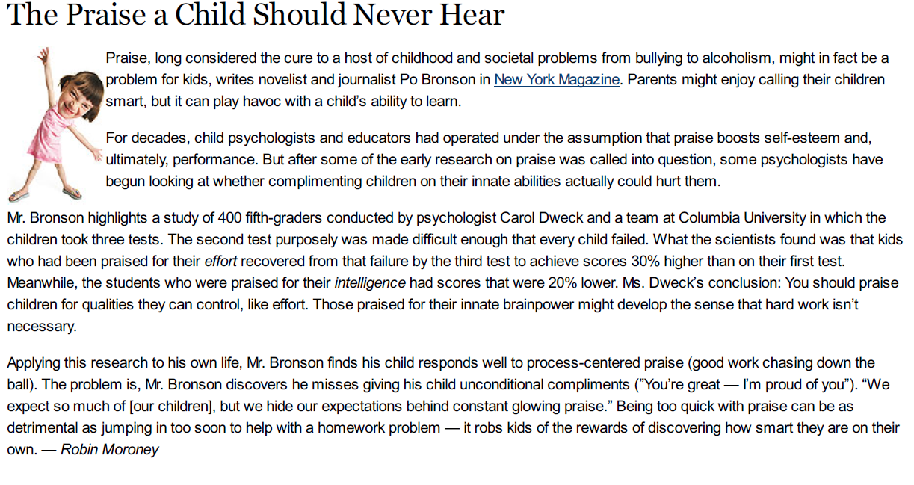 [1]

Inspection Report for Written Work

Question This Report Answers: ________________________________________
Written by: Robin Moroney

Assessed by:

Date:

Checking for clarity:  Summarize in your own words so the author knows whether you understood |  | Checking for consistency:  How does your real-world experience contradict or support this?
Title and author of original source | How Not to Talk to Your Kids: The Inverse Power of Praise (Po Bronson, New York Times Magazine)

Inspection Report for Hands-On Work
Soldered by: | J Smith
Inspected by: | M DiPenta
Pre-soldering Checks | Documentation
Date that personnel proficiency was last documented on skill sheet
Date of tool, material, and process testing
Solder type
Solder bath impurities within accepted limits? | Y / N / NA
Workstation cleaned before beginning? | Y / N
New or specialized materials or processes? | Y / N
If yes, where are testing results found?
Gold-plated contacts? | Y / N
If yes, where is solderability process found?
ESD-sensitive components? | Y / N
If yes, where is ESD procedure found?
Heat-sensitive components? | Y / N
If yes, where is heat-control procedure found?
Post-soldering Checks
Visual inspection magnification power | 3x / 7.5x / 10x / 20x
No broken strands | □
No damage to component bodies | □
No damage to component lead seals | □
No component internal surfaces exposed | □
No components trimmed beyond meniscus | □
Clearance maintained between metal case components and exposed circuits | □
No adhesives interfering with solder | □
All stacked parts maintain electrical clearance | □
All through-hole joints are 100% filled, 360 degree wetted on both sides, filleted | □
Cleaning process C-20 completed (both sides cleaned with FR, isopropanol) | □
Visual inspection shows no signs of marks, scratches, flux residue, dirt, contaminants | □
No damage to board's edge or surface | □
No lifted lands | □
No measles | □
No conformal coating added | □
Soldering Technician's Signature
Date
Inspector's Signature:
Date:

Comprehension Constructor

D-Shell Connector
Name: __________________________________
Shape: Trazepoid-shaped shell, flange mounted into backshell  Formal Names:  Informal Names:  Varieties:  - Number of Pins:  - Contact types: | 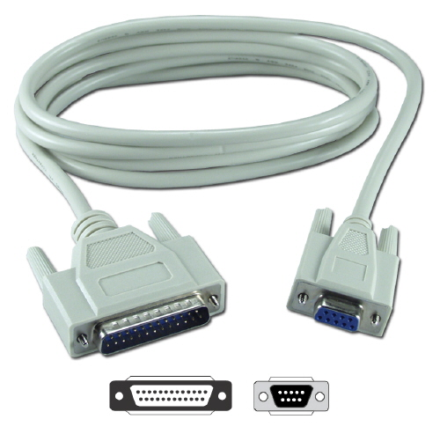 (1)

Normal current expected to flow: __________________________  Max current expected to flow: _____________________________  What wire gauge did you use? Why? | On the connector, label the pins, shell, flange,and backshell  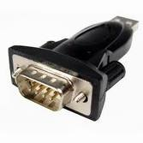

Easy-Medium-Hard
EASY | Series Circuits  p. 123, Q# 12-14  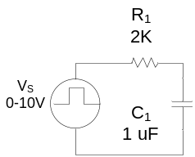 | Name  Date | Include:  - Show:  - Your name  - Date  - Title (“Series Circuits”, or etc.)  - Page #  - Question #  - Schematic  - What you’re trying to find  - The formula you used,  with subscripts  - Use engineering notation at all times  - Show units at the end of all calculations  - Label voltages and currents as DC, peak, peak-to-peak, RMS, etc.  - And all other best practices for technical writing!
EASY |  | Find C_{T}.  Reasoning shown neatly here  Lots of blank space between question

An EASY question is one that you could solve in your head.
A MEDIUM question is one that you can’t solve in your head but you know how to do.
A HARD question is a true “problem”: it is one that you don’t know how to do yet.

- Choose an easy question from the odd-numbered items in the back of the book. Draw the schematic on your paper, and write down what you’re trying to find.
- Close the book.
- Solve the problem as far as you can.
  - If you did not finish the problem, write a question about what information you need in order to continue. See me if you need help.
  - If you finished the problem, check your answer in the back of the book and mark it right or wrong.
- If you didn’t complete the problem correctly, choose another easy question and repeat. Continue until you can solve an easy question.
- Repeat steps 1-4 with a medium question.
- Choose a hard question. Write it down. Make a note about what you’re not sure about or don’t know how to do.
- That’s it! Turn in to teacher.

